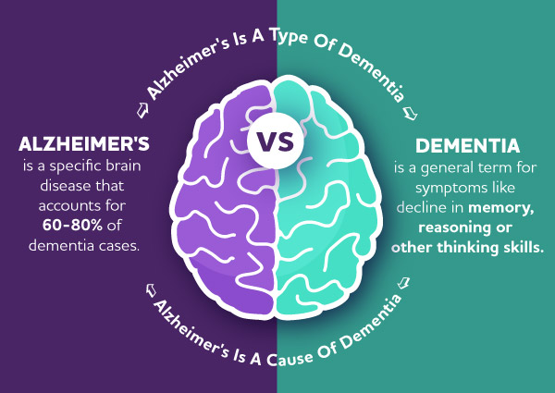
- Categories of resources for caregivers for each stage of Alzheimer's. There are also care training resources here, as well as good tips for caregivers to take care of their own selves first in order to be able to care for others well: https://www.alz.org/help-support/caregiving
- Great local support group who meet on campus for caregivers of folks with Alzheimer's and Dementia: https://seniornavigator.org/program/21135/caregiver-support-group

- The Alzheimer's Association Helpline is available 24/7 for folks in crisis who need to talk to a master level clinician: https://www.alz.org/help-support/resources/helpline

- The Eldercare locator can help folks find local resources for caregiving, support services, adult day care, etc. https://eldercare.acl.gov/Public/Index.aspx

- Comprehensive list of resources to help caregivers find the supports that their loved ones with Alzheimer's and Dementia may need: https://www.nia.nih.gov/health/getting-help-alzheimers-caregiving

- More helpful resources for Dementia care: https://www.caregiver.org/health-issues/dementia

- Caregiver Action Network Family Caregiver Toolbox (this one is great): https://caregiveraction.org/family-caregiver-toolbox

